College Degree Requirements Misguided
By David Brauner, Publisher
When I know about half of you disagree but the college degree requirement for Certification was a wrong turn for the industry. To its credit the Appraisal Foundation (TAF) is on the right track in trying to find a way out of the corner it has painted the profession into but it doesn’t look like it intends to go far enough in fixing the problem. As we all know by now, veteran appraisers as well as newbies can be licensed without a college degree but not Certified. Because so much of the business today depends on being Certified, not holding that license level can be a very limiting condition indeed: it disqualifies appraisers from most AMC and lender panels and excludes them from working for the FHA. A lack of opportunity has driven many good appraisers from the business and for the first time in a long time, there is a shortage of new appraisers entering the profession. This is not good news.
Without new vitality to innovate the profession, it will wither and die. Lenders will create alternative solutions that combine big data and low-fee “property inspections” for all but the most unique properties to replace appraisers. To the current “shortage” of appraisers you may be shouting “Hallelujah!” while you enjoy some long-overdue increases in your fees. But if you’re really honest with yourself you must agree that a college degree is no predictor of good work or good behavior (there are far too many examples from our profession and others that make that statement sadly ridiculous). Training, testing and time can separate the wheat from the chaff when combined with consistent enforcement. Effective oversight will identify repeat violators and patterns to reveal who won’t or can’t adopt accepted techniques or who refuse to play by the ethical rules. We all agree these types should be expunged from the ranks but a college degree does not guarantee competency or ethical behavior: so what is it about?
The college degree requirement seems more like a forced attempt at elevating the status of the profession by closing the club, and that strikes me as elitist. Not everyone has the opportunity, resources or aptitude to attend and/or flourish in college. Some very smart people just don’t learn via traditional education methods. And holding up the education requirements of other professions like attorneys, doctors and CPAs just does not hold water. An accountant is a more apt comparison and while a college degree is recommended, it is not required to become an accountant, nor is it to become an engineer, software developer, airline pilot or journalist for that matter. A recent letter from a reader points out that a degree is not even required to be President of the United States! The requirement is even more dubious when you consider that a degree in any subject passes muster for becoming a Certified Appraiser, no matter how unrelated (think French Literature for instance), while someone with the skills to flourish in this business would be shut out for all intents and purposes without a degree.
The folks at TAF tell WRE that they are looking into alternative paths to Certification for veteran appraisers with “a track record of professional (appraisal) experience.” That’s very good but not good enough. The college degree requirement for new appraisers ought to be replaced by some combination of education, coursework and testing so that a whole new generation of young, smart and tech-savvy entrepreneurs has a chance to contribute to the profession, whether they are cut out for college or not. Many young candidates will be your sons or daughters or grandchildren. Are they all destined to graduate college? Like you, they should be able to enjoy a profession that allows them to be their own boss while making an honest living and a valuable and rewarding contribution to their community. To dig in on this issue and leave the college degree requirement in place for prospective appraisers without any reasonable path to Certification risks the future of the profession and turns away many men and women who could add to its legacy.
TAF believes there is no opposition to the college degree requirement among appraisers. Whether you agree or not, you can share your opinion and feedback with Working RE’s new Future of Appraisers Survey. We will publish the results for all to see, whatever you decide.
The AQB will hold another public meeting on these issues on Friday, April 8, in Phoenix, Arizona. For more information: https://www.appraisalfoundation.org/TAFCore/Events/Event_Display.aspx?EventKey=AQB201604.
Take Survey Now
Let your voice be heard! Share your opinion on the college degree requirement, trainee experience requirements, and more with Working RE’s short, six-question Future of Appraisers Survey.
Working RE Webinar Series Savings
January: Persistent Appraisal Failures ($49 - Available Now)
February: Appraisal Adjustments: Solving Common Problems ($79 – Available Now)
March: Complex/Unusual Properties ($79 – Available Now)
Save $48 when you purchase the Winter Series Season Ticket (five webinars)!

About the Author
David Brauner is the Senior Insurance Broker for OREP.org and Publisher of Working RE magazine. He has been involved in providing E&O coverage for appraisers for over 20 years. OREP is a leading provider of appraiser E&O insurance. All OREP Insureds enjoy unrivaled professional support, including free state board complaint consulting, free webinars, guaranteed delivery of Working RE Magazine, Continuing Education coursework at cost, and discounts on background checks, office supplies, cell phone bills, rental cars, and more. Shop OREP Today!

http://www.workingre.com/uspap-ce-online-at-a-discount/

http://orep.org/appraisers-eo-insurance/
http://www.workingre.com/uspap-ce-online-at-a-discount/
http://www.cvent.com/d/kfq2lr

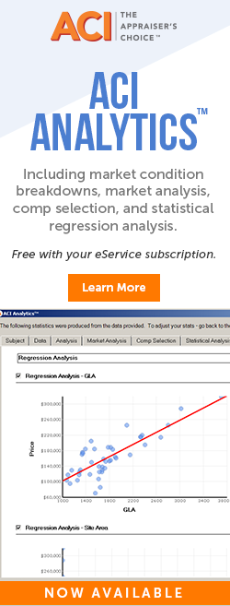
http://www.aciweb.com/aci-analytics-provides-market-analysis-comp-selection-and-statistics/

